Detecting and Decoding Barcodes in Images
I Abstract
Research was conducted into interpreting barcodes in blurry and low-resolution image data from camera phones. First, a survey was conducted into current methods of localizing and decoding barcodes within images. It was determined that while most existing methods functioned correctly in ideal conditions, they were not sufficiently robust for poor image data. Thus, a new method was successfully developed for locating a barcode within an image and another for decoding it.
II. Introduction
For the past several decades, handheld laser scanners have allowed workers in stores to read barcodes in order to obtain product information. In the future, it would be desirable for consumers to read barcodes via handheld camera phone. This could allow consumers to quickly obtain product descriptions, reviews, and pricing information.
While current methods exist to interpret bar codes, they are often not robust for dim, unfocused, or low-resolution image data often provided by phones. In addition, many current implementations require the user hold the phone within inches of the barcode rather than taking pictures from a greater distance. These factors limit the usability of this technology.
In general, interpreting a barcode within an image consists of two steps. First, the barcode must be localized within the image. Next, after the barcode is found, it must be decoded. This second step entails determining the length of each bar within the barcode.
The goal of this project was to first survey existing methods of localizing and decoding barcodes to see if they met our needs. These methods were at times altered and extended to improve performance. In addition, new methods were successfully developed for locating a barcode within an image and another for decoding it, in hopes that they would offer an improvement over existing methods.
III Barcode Localization
The first step to interpreting a barcode is to localize it within an image. More specifically, we must find two points which correspond to the left and right outer edges of the barcode. This section presents various methods to do this which were implemented during the course of the research.
- Locating 1-D Bar Codes in DCT-Domain
The first method to be implemented is described by Alexander Tropf and Douglas Chai in their paper Locating 1-D Bar Codes in DCT-Domain. In this method, a DCT is computed on each 8 by 8 block of pixels in the image. This produces 8 by 8 DCT blocks, which essentially encode frequency information from the image. All of these DCT blacks are averaged in order to produce a single block, which is representative of the image as a whole. Dominant frequencies and their corresponding directions are found in this averaged block. These dominant frequencies and directions are assumed to correspond to the barcode. The barcode may then be localized by searching for an extended region with the appropriate directionality.
Sample results, obtained through my implementation of this algorithm, are shown below:
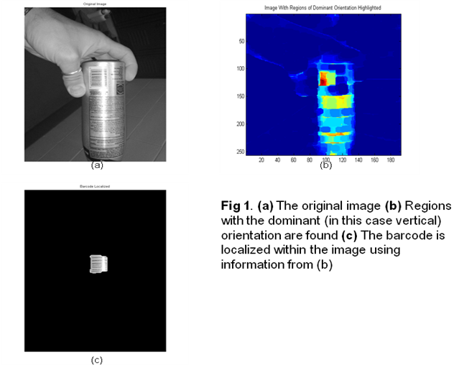
Overall, it was found that this method was insufficient to meet our needs. In particular, the assumption that the dominant directionalities in the average DCT black correspond to those of the barcode is problematic. If the barcode makes up only a small portion of the image, or if there are many other objects and edges of other directionalities, then the average DCT block will not reflect the information from the barcode alone and the algorithm will thus fail. This method may be improved by somehow learning the directionality of the barcode from individual DCT blocks directly, without averaging over the whole image.
- Automatic Real-Time Barcode Localization in Complex Scenes
Another method implemented in the course of this research, described in the paper Automatic Real-Time Barcode Localization in Complex Scenes by Chunhui Zhang, Jian Wang, Shi Han, Mo Yi, and Zhengyou Zhang, takes a decidedly different approach from the DCT method. Instead of using a frequency domain approach determine the directionality and location of the barcode, this method uses image derivatives at angles of 0, 45, 90, and 135 degrees. From these operations, the angle of the barcode may be determined to the nearest 45 degree. After numerous processing steps are taken, a more precise estimate of the barcode’s angle is obtained. The barcode is found by searching for a region with a large number of lines in this dominant direction. Sample results, obtained from my implementation of the algorithm, are shown below:

(a)

(b)
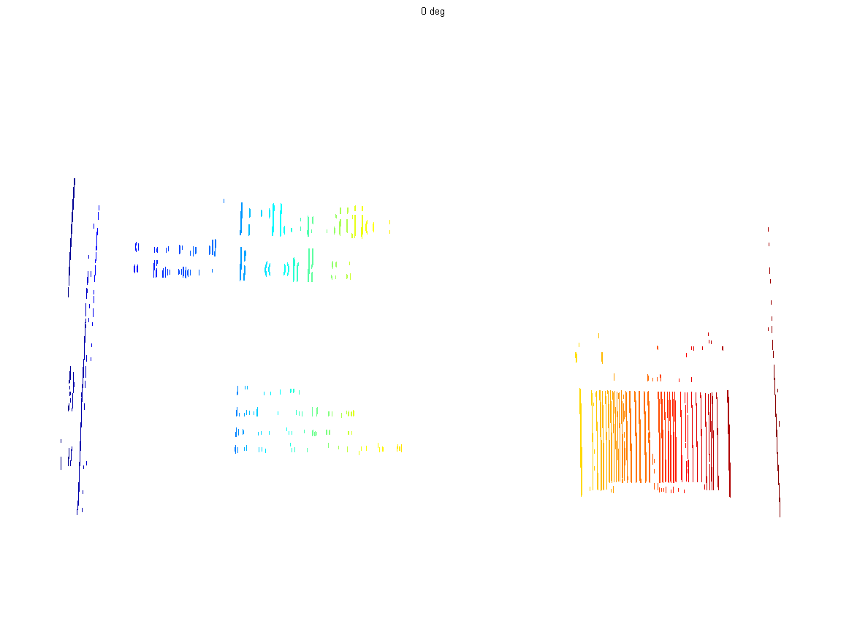
(c)
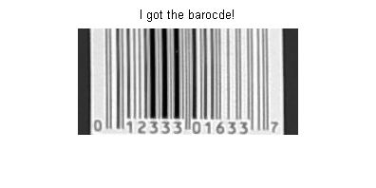
Figure 2: (a) Original image (b) Directional derivatives are taken at 0, 45, 90, and 135 degrees. Edges from the 0 degree derivative are shown here. This is determined to be the dominant orientation. (c) The barcode is identified as the region with the most edges at 0 degrees.

Two major problems were encountered during implementation of the algorithm. The first step of the algorithm as it is laid out in the paper is to model lighting as “an additive 2nd-order surface” and then “divide it from the original image to get a uniformly illuminated image”. However, the paper does not describe how this is done and does not cite any sources to explain the approach taken. Thus, this step was skipped in my implementation.
Additionally, it was often not straightforward to pick out the correct directionality from the derivatives taken at 0, 45, 90, and 135 degrees. This is because many extraneous edges which do not correspond to the barcode are picked up by these derivative operations. Thus, if there is too much background activity, the wrong direction may be chosen. Erroneous results may occur despite numerous steps taken to minimize noise and incorrect edges.
Overall, this method was found to work in many cases, but not all. The problem of derivates picking up non-barcode edges is especially problematic. The algorithm is also very complex and inefficient because it calls for numerous steps of processing.
- Difference of Gradients Method
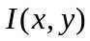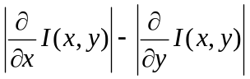A unique method for localization developed in the computer vision lab at UC Santa Cruz is discussed in this section. The key assumption is that a typical barcode consists of vertical bars. Thus, we may locate the barcode by looking for an extended region with high horizontal gradients and low vertical gradients. Based on this intuition, we apply the following operation to an image :
(1)
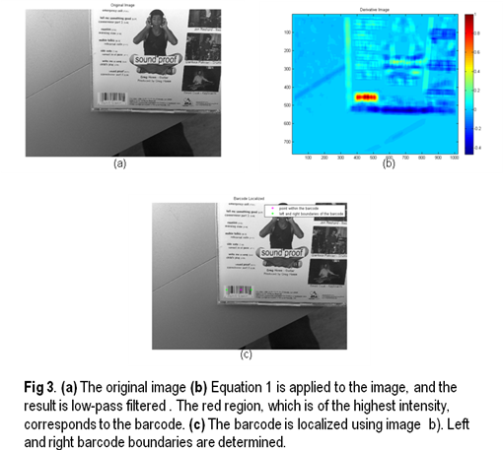
Afterwards, we low-pass filtered the result to eliminate isolated edges and noise. The point where this operation is maximized is assumed to be located within the barcode. From this point, we move outwards to establish precise left and right bounds for the entire barcode. This process is shown pictorially below:

In general this methodis efficient, fast, and has high accuracy. Unlike the previous method, edges in the incorrect orientation are subtracted out in equation (1), which greatly reduces the number of non-barcode edges picked up. Its major flaw is that, unlike the methods described in parts A and B, it assumes that the barcode is horizontal. This implies that if a barcode is vertically aligned, as sometimes occurs on the side of soda cans, it may be missed. To compensate for this, we may extend this algorithm. For example, we may decide to search for vertical gradients by using a variation of (1). Then, we can decide whether the barcode is vertical of horizontal by looking at the magnitude of each operation.
IV Barcode Decoding
After the barcode is localized using one of the methods in the previous section, it must be decoded in order to obtain the product’s information. Decoding a bar code entails finding accurate estimates for the thickness of each bar in a barcode. This section discusses two methods to accomplish this.
- Applications of Hidden Markov Models in Barcode Decoding
One approach, discussed in Applications of Hidden Markov Models in Barcode Decoding by S. Kresic-Juric, D. Madej, and Fadil Santosa, applies the statistical machine learning framework of a Hidden Markov Model (HMM) to the problem of barcode decoding. The first step is to obtain a scan-line of the barcode, using the left and right boundaries obtained by localization. Next, the inflection points of the scan line are computed. Most of these inflection points correspond to the endpoints of each bar, but some simply correspond to noise. The HMM is used to determine which inflection points are noise, and which are endpoints of each bar. Each state in the HMM is a pair of inflection points. For example, a state may consist of the left and right edges of a black bar, the left edge of a white bar and a noisy point, or other similar combinations. For each pair of points, there are several observations we may make. In this case, we measure the derivative of the scanline at each point and the distance between adjacent points. The HMM determines which sequence of states best explain our observations. This framework thus allows us to distinguish between noise and actual bar endpoints, as shown below:
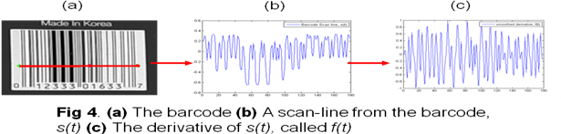

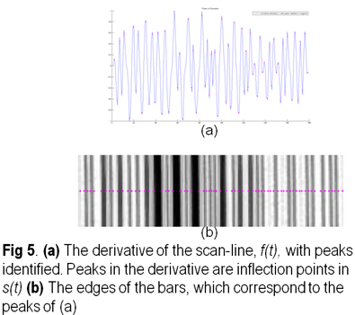

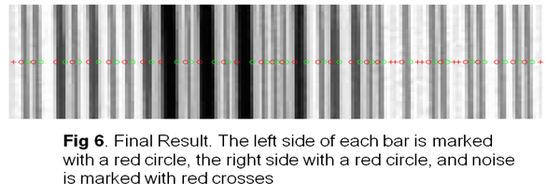
- A Minimum Path Approach to Barcode Decoding
A unique approach to barcode decoding was developed based on Dijkstra’s shortest path algorithm. The algorithm begings in much the same way as the previous algorithm, using the same techniques to find potential bar edges. These potential bar edges, also called “nodes”, are shown in pink in fig 7. After this is done, a cost is assigned to each node and each possible transition between nodes. This cost depends on various statistics on the pixels between the edges, such as the average intensity between the two edges, the slope at the edges, and the length of the bar. It is hoped that false bars which correspond to noise will receive a high cost, and real bars will receive low costs. After this is done, Dijkstra’s algorithm is used to find the best path through the bars, which is the path which minimizes the sum of the costs of all the nodes and transitions in the path. Ultimately, it is hoped that this path skips over the noise and identifies the true bars. The process is demonstrated below:
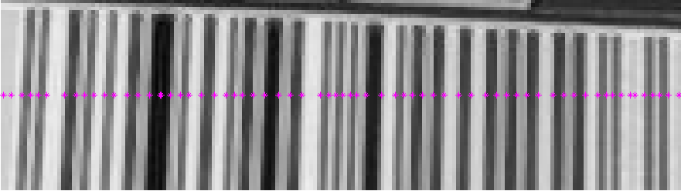
Figure 7: The barcode with potential peaks identified. Note that several false peaks are included. A close up of the segment boxed in red is shown in Figure 8.

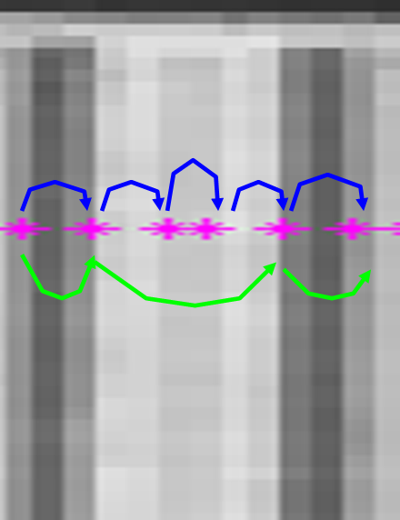
Figure 8: A segment of the barcode, with a false black bar in the center. Two sample paths through this portion of the barcode, shown in green and blue arrows, are shown. In order to determine which is best, a cost is assigned to each arrow depending on such factors as intensity, bar thickness, and slope. Dijstra’s algorithm will then choose the best path (hopefully the green one).

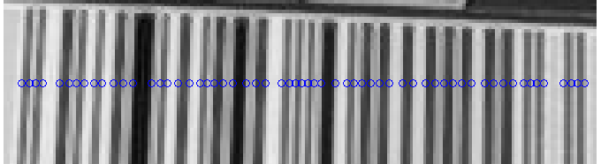
Figure 9: The best path through the bar is found. Note that the false bar shown above is not included.

In order to achieve best performance, close attention must be paid to assigning a cost to each node and transition. Currently, a cost is assigned to each node based on the slope at this point. The slope is indicative of how sharp the transition is from black to white (or vice versa), and thus a large slope implies a very clear, well-defined bar. Additionally, a cost is assigned to each transition between nodes. This is based in part on the length of each bar. Since it is known that bars come in one of four sizes, and thus a cost may be assigned if a bar is not of the correct length. The intensity of each bar is also taken into account into the cost of a transition. Bars which are gray in color are given a higher cost than bars which are dark black or pure white. Lastly, a higher cost is given to transitions which skip over peaks in the derivative, because these transitions are likely to miss entire bars in the barcode.
This algorithm compares admirably to the HMM approach. It seems to yield better results, and is simpler to implement and more intuitive. However, it does not reliable decode extremely blurry barcodes. More work is needed to achieve optimal results from this method. The manner in which the costs for edge transitions are computed needs to be fine-tuned, and the efficiency of the current implementation may be improved.
V Conclusions
It was found that the existing methods for localization and decoding of barcodes were sufficient in clear images with minimal background activity, but were insufficient for more difficult images. As such, two new methods were developed to accomplish these tasks, and were demonstrated to be superior to existing methods. The new method for locating barcodes within an image, based on the difference between partial derivatives of the image taken in the x and y directions, was robust even when there were many other objects and potential distracters in the background. The new method for finding decoding barcodes, based on Dijkstra’s best path algorithm, appeared to be a slight improvement over previous methods, but the algorithm still must be revised and optimized.
VI References
[1] Kresic-Juric, S., D. Madej, and Fadil Santosa. "Applications of hidden Markov models in bar code decoding." Pattern Recognition Letters 27 (2005): 1665-672.
[2] Rabiner, Lawrence R. "A Tutorial on Hidden Markov Models and Selected Applications in SPeech Recognition." Proceedings of the IEEE 77.2 (1989): 257-85.
[3] Tropf, Alexander, and Douglas Chai. "LOCATING 1-D BAR CODES IN DCT-DOMAIN." ICASSP 2 (2006): 741-44.
[4] Zhang, Chunhui, Shi Han, and Zhengyou Zhang. "AUTOMATIC REAL-TIME BARCODE LOCALIZATION IN COMPLEX SCENES." ICIP (2006): 497-500.

